Lab 2:

Windows

storage systems

Datacenter Virtualization

2024-2025

© Daan Pareit

CONTENT

1 Introduction 3

1.1 Learning goals 3

1.1.1 Knowledge 3

1.1.2 Skills 3

1.2 Prerequisites 3

2 Installing Windows Server 4

2.1 Preface 4

2.2 Installation 4

3 Virtual Hard Disks (VHD) 8

3.1 Preface 8

3.2 Create a VHD via the GUI 8

3.3 Create/manipulate VHDs via CLI 10

4 Storage Spaces 16

4.1 Preface 16

4.2 Preparing by adding disks 16

4.3 Create a Storage Space 17

4.4 Emulate disk failure and repair 25

5 Data Deduplication 29

5.1 Preface 29

5.2 Configuration 29

6 iSCSI server 33

6.1 Preface 33

6.2 Configure iSCSI 33

# 

# Introduction

Today, we will work with Virtual Hard Disks (VHDs) and learn how to configure special Windows storage features like Storage Spaces and Data Deduplication.

Finally, as it is quite easy in Windows, we will also turn our Windows Server VM into an iSCSI SAN…

## Learning goals

### Knowledge

* Know what a VHD is
* Know what Storage Spaces and Data Deduplication are

### Skills

* Be able to create and manage VHDs
* Be able to configure and extend Storage Spaces
* Set up an iSCSI SAN on Windows Server

## Prerequisites

This lab will be performed on Windows Server 2025, but note that most features are available as well on Windows 11 if you would ever need these.

You’ll need the following:

* About 18 GB of free disk space ☹
  + 5 GB for downloaded iso file
  + 13 GB for fresh installed Windows Server VM
* Go to Microsoft Evaluation Center for Windows Server:   
  https://www.microsoft.com/en-us/evalcenter/download-windows-server-2025

Download the 64-bit ISO file for Windows Server 2025

# Installing Windows Server

## Preface

We will now install a VM with “Windows Server 2025 Datacenter with Desktop Experience”. This should only take a few minutes.

## Installation

Follow these steps:

* Create a new VM, choose to install a ‘Windows Server 2025’

I went for the Windows 10 x64 because in the other version there is no such thing as Windows Server 2025

* Choose ‘I will install the OS later’ to avoid VMware’s ‘Easy Install’ to kick in.
* Choose a name and location for the VM files. Preferably this location should not be synchronized with the cloud (onedrive) to avoid instability.
* Keep the proposed disk (60 GB) and RAM (2GB) size. Store the virtual disk as a single file.
* Use the Windows Server ISO image file in your DVD drive, and boot from that DVD.
* Go for the “Install Windows Server” option to do a clean install
* Choose the installation option “**Datacenter** Evaluation” **(Desktop Experience)**”.

Almost missed this one

* Near the end of the installation process, choose a password for Administrator, e.g. ‘Server2025’. (Note: num lock is by default off.)

password - Server2025

* After logging in for the first time, in command prompt, execute ‘sconfig’ and choose to set Updates to ‘Manual’. Security wise, this is NOT a good idea, but this is no production environment here and we set this option to avoid your VM taking more disk space.

* In VMware Workstation choose to ‘Install VMtools’. In your Windows, this will appear as an inserted CD. Start setup64.exe there and complete the setup.

* To enable your num lock on the login screen, start regedit.exe and :
  + Go to HKEY_USERS\.Default\Control Panel\Keyboard
  + Change the value of InitialKeyboardIndicators to 2

To gain back some disk space: shutdown your VM and in VMware workstation choose ‘Manage – Clean up disk space’.

For your convenience, you could take a snapshot of this cleanly installed VM.

# Virtual Hard Disks (VHD)

## Preface

VHDs are **very** similar to VMDKs of your VMware Workstation/Fusion/Player: they are block level files that can contain file systems on their own and that can be mounted. In that respect, these are very similar to loopback devices on Linux, VDI files for VirtualBox and so on …

When using Windows Backup (Complete PC Backup), VHDs are also used. And finally, the LUNs for iSCSI Targets in Windows Server are primarily VHD(x) based…

VHDs have some very nifty features:

* they can dynamically expand,
* they can be attached and detached as block device since Windows Vista,
* they can be put on thumb drives, external drives and even network drives and in some cases attached (or mounted) from that location.

→ And it is even perfectly possible to **install Windows** on a VHD, marking the bridge between a virtual and a physical environment…

→ For example: We can use a normal Windows 11 laptop and install an additional OS on a VHD that resides on a file system and select to boot from it whenever we want. Watch out: a dynamic VHD will expand to its created size for the duration of the OS runtime.

## Create a VHD via the GUI

We’ll now play with VHDs on Windows Server, but this is equally possible on a regular Windows 11.

1. Start the VM and open ‘Disk Management’ . This can be done in multiple ways: via the Win-X shortkey, or via diskmgmt.msc or via mmc.exe with appropriate snap-in.
2. Open the Action menu and select “Create VHD”.

→ Note the difference in recommended action between VHD and VHDX format

1. Create a VHDX (C:\disk1.vhdx) with a size of 1TB. (Yes, 1TB, consider the note in the line above.)  
   Use the recommended settings. Note that the VHD is also listed as a disk in Disk Management.

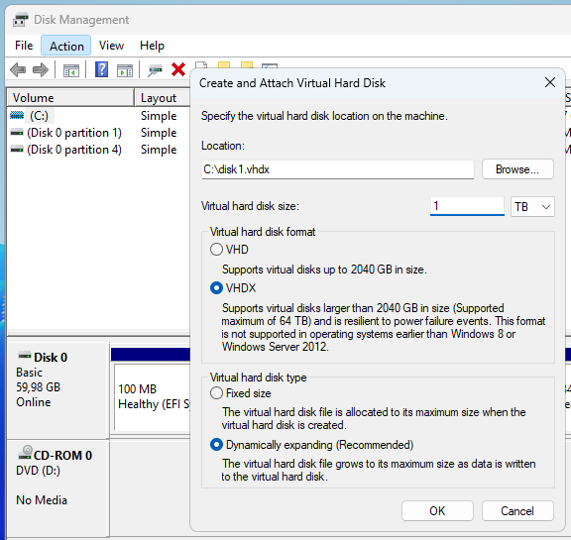

* 1. Open Explorer and find the newly created VHDX file, what is its current size?

4096 KB

* 1. Initialize it using the GPT scheme, look at the size again, any difference?

69632 KB

68 MiB

1. Create a new partition, which Windows refers to as a ‘simple volume’, which takes all available disk space and select the **ReFS** file system to format your partition with. Note that this file system type is only available on a Windows server edition, not on a Windows client edition. Perform a Quick Format and assign it a drive letter.

**Q: What does “REFS” stand for? Would you use it?**

**It stands for Resillient File System, most probably yes since it is newer and has more flexibility and overall looks like a better option for servers, however as everything in development from Microsoft - it might be a problem**

* 1. Look at the size of the VHDX file itself one more time after formatting your partition/drive.

364544 KB

* 1. **Put some data** on that drive and see it grow. To generate random data, you can use the ‘fsutil’ command in a command prompt. Type ‘fsutil file’ to see different options and create a file of 10 MiB on your new drive.

fsutil file createnew E:\myfile.txt 10485760

do not forget to attach the VHD just in case.

## Create/manipulate VHDs via CLI

To work with VHDs on the CLI, we’ll use ‘diskpart’ in Windows.

1. Start ‘diskpart’ on a command prompt.
   1. Type *help* to get help 😊 and see the different commands within diskpart
   2. You can get specific help for each specific command, e.g. type: *help* *list*
   3. List all disks (*list disk*) and all volumes (*list volume*)

* 1. Select the Virtual Hard Drive. (Use help on how to do so.) Now type *detail disk* and review the details. Notice that the path is “unavailable”. Compare the output when selecting the first disk.

It knows what are he used devices and it is not a virtual environment

* 1. Run *help list* to find the command to list all VHDs known to diskpart. It shows which vhds/files are mapped to which disks and their status.

select vdisk file=”c:\disk1.vhdx”

* 1. Now detach the attached vdisk. Take note of the commands required for this.

detach vdisk

* 1. Verify in your Windows Explorer and in your Disk Management GUI that the drive/disk are indeed no longer available/attached.

1. Let’s go beyond the functionality offered via the Disk Management GUI and use a feature only possible via CLI: creating a child disk out of a parent disk.
   1. In Diskpart, type: *help create vdisk* and review the functionality

**Q: What does the “source” parameter mean (versus the “parent” parameter)?**

**source specifies the virtual disk file to copy information block by block.**

**parent is for information of the child disk, like size and other information.**

* 1. Create a child vdisk “C:\child1.vhdx” out of your original vdisk (and thus still relating to that original disk). What parameter to use: ‘source’ or ‘parent’?

create vdisk file=”c:\child1.vhdx” parent=”c:\disk1.vhdx”

* + 1. Do not specify a size and do not specify that it is expandable, which options are selected for us concerning disk size and fixed/expandable type? Hint: it was also in the help?

it says it will be FIXED and NOT EXPANDABLE

1. Also look at the size of this new child VHDX file itself before attaching it.

8192 KB

* 1. Verify using *list vdisk* that your new VHD is created and selected (selected entries are marked with * in a list).

* 1. Verify using *detail vdisk* the child-parent relationship of your vdisk.

* 1. Now attach this newly created disk file via diskpart (and verify in Disk Management and Windows Explorer).

attach vdisk (since it is already selected)

1. Have a look at the file size of your child1.vhdx. With this child attached, then delete the 10 MiB file you’ve created before (using fsutil) from the volume.

**Q: Does the child VHDX grow, stay the same or shrink when we DELETE all files from the attached volume? Try to predict (and explain) the result**

**I did not expect it to actually grow in size, and I do not understand why it does it.**

**Thankfully to amazing helpers it appears that the disk (child) stores differences from the parent file, and also other information, which makes it grow apparently.**

1. Using diskpart or Disk Management, attach the parent VHDX.

**Q: Explain why this fails and what would be needed to make it work (without detaching the Child VHDX)**

**It fails because it is being used by the other disk, which is the child in this case.**

**I do not know how to attach it back, but most probably the changes need to be on both the disks and then it would work.**

1. Open Windows Explorer and navigate to the child VHDX, make a copy of this VHDX. For example: hold the “Ctrl” key and drag it to the same folder. Rename this “child1 - copy.vhdx” to “child2.vhdx”.
   1. Now make sure that both child1.vhdx and child2.vhdx are attached and online.

* 1. Is child2 still linked to the same parent? Find out with *detail vdisk*

It says that the parent filename is disk1 still.

* So now we have two hard drives that are usable and work completely independently from one another. Files can be moved, deleted and added, while keeping the files on the parent VHDX intact…
* Note that it is entirely possible to create additional child VHDs from child VHDs.
* This concept is exactly the same as how Snapshots for Virtual Machines work

# Storage Spaces

## Preface

This feature, (present since Windows 8) tries to provide a solution which is comparable to LVM on Linux.

The main difference with LVM, however, is that it DOES provide redundancy as well. So it actually does not require an underlying RAID configuration.

It also works on ANY hardware layer like USB, SAS, VHD, SATA etc …

## Preparing by adding disks

To prove that Storage Spaces can work with both physical disks and virtual VHDs, we’ll add both to our VM.

* Let’s make it simple and first remove **ALL VHDs** from the previous exercise.

* Open the VM settings and add one **SCSI** hard drive of 500GB in size, make sure it is online and (GPT) initialized.

* Then add two new VHDX files: ***C:\file1.vhdx* (size 1TB) and *C:\file2.vhdx* (size 5GB).**

*This gives us 3 different disks to play with Storage Spaces*

## Create a Storage Space

Now, we’ll create the storage pool using ‘Server Manager’. Microsoft is promoting the ‘Windows Admin Center’ web interface as its alternative, but managing Storage Spaces is not included therein (yet).

1. Open “Server Manager”, wait some seconds until “File and Storage Services” becomes visible and select it. Go to Volumes > Storage Pools.

*All our empty disks should be visible*

1. Right click Primordial and select “New Storage Pool…”

* 1. Call it “Pool1-<firstname>-<lastname>” and select the 5GB Virtual Disk and the 500GB Hard Drive.

1. Now right click on the new pool and create a new Virtual Disk with the name “vDisk1-<firstname>-<lastname>”

* 1. Use the defaults, but at Storage Layout, try to use “Parity”.  
     **Q: Why can’t we use Parity here?**

For parity we need more disks, otherwise it does not work.

* 1. Then select Mirror with Thin Provisioning and a size of 10GB.
  2. Also create a default Volume on it (NTFS is OK).

1. Review what we just did:   
   - We created a Storage Pool over two hard drives (like a VG over 2 PV’s with LVM)  
   - Then created a virtual disk within this pool (like a LV with LVM)  
   **Q: Open Disk Management and note down what you see there. Did you expect this? Why are we missing some disks and seeing others?**

this was expected, as we used 2 disks in order to create one pool, hence it is normal to use it and show it like that. We only used 10 GBs out of the pool, hence it might seem odd, however this looks totally right to me.

The disks are just invisible for us, so that we do not do anything stupid with them.

1. Let’s use an alternative way to put data on our new NTFS volume:
   1. Open a Command Prompt and navigate to the drive letter of the newest volume
   2. Type this command: *fsutil file createnew file1.out 512000000*→ That is 512 and six (6) zeroes  
      **Q: How large is the file we just created?**

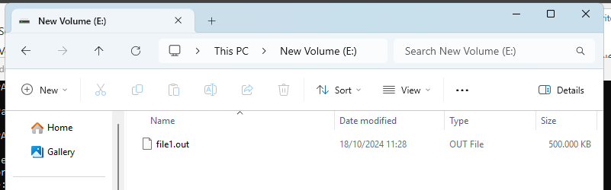

488 MiB

* 1. Execute the command again (for *file2.out*), and keep repeating it for file3, file4 etc… until we start to see error messages  
     **Q: What error message do you get? Explain why we run out of disk space, while the volume is not full at all. Hint: check the vDisk properties**

Error 112: There is not enough space on the disk.

It makes sense that we run out of space, since we used a 5GB and 500GB for MIRROR. Hence, no more data can be mirrored, and we fail!

1. To demonstrate the flexibility of Storage Pools over RAID: add the 1TB Virtual Disk to the Storage Pool “Pool1-<firstname>-<lastname>”. Then retry the last command that failed in the previous step (for creating yet another file). This should now be possible. Mirroring files is no longer limited to the smallest disk but can be spread over different disks.

**Q: After expanding your storage pool with the 1TB vhdx, take a screenshot of your 'Storage Pools' section in Server Manager including: your storage pool, your virtual disk (storage space) and the physical disks included in the pool. Pool and vdisk should include your name.**

## Emulate disk failure and repair

1. Now, let’s demonstrate the redundancy feature of our Storage Pool. Add the ‘bart_simpson.zip’ on your storage space drive (zip file is on Leho, which we used in the previous lab). In your VM setting, remove the 500 GB disk to emulate a disk failure. In Storage Pools, you might need to refresh to view to missing disk.

**Q: Are you still able to open the zip file and view the files therein? Why? What is the Health status of your vDisk storage space?**

**I am not able to open/view the files anymore. This is probably because we added some more space afterwards, and the data was stripped to it as well, hence the data can not be accessed once some chunks of it are not available anymore.**

**The status is**

**Warning: Degraded; Incomplete (for the Virtual disks)**

**Warning: Lost Communication (for the physical disks)**

1. To have a redundant mirroring Storage Pool again, you’ll have to add a replacement disk. Open the VM settings and add another **SCSI** hard drive of 500GB in size, make sure it is online and initialized. Add this new replacement disk to your Storage Pool and then remove the failing disk from the Storage Pool (the one you’ve removed from your VM before). This could take a minute to complete. Upon completion, in Storage Pools, you might need to refresh to view that all warnings are gone, and you have everything OK again.

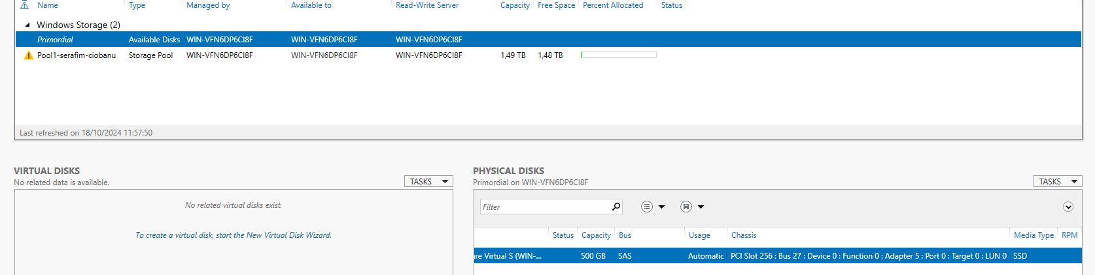

First add the disk

and then you can start removing it

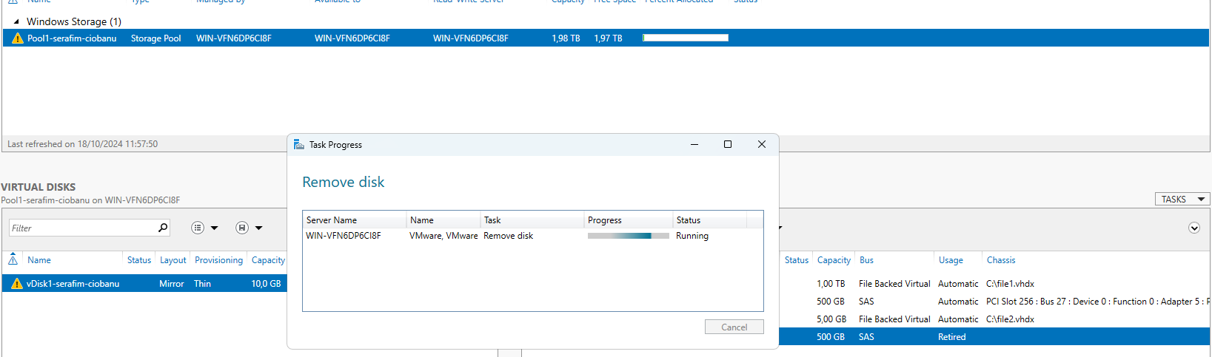

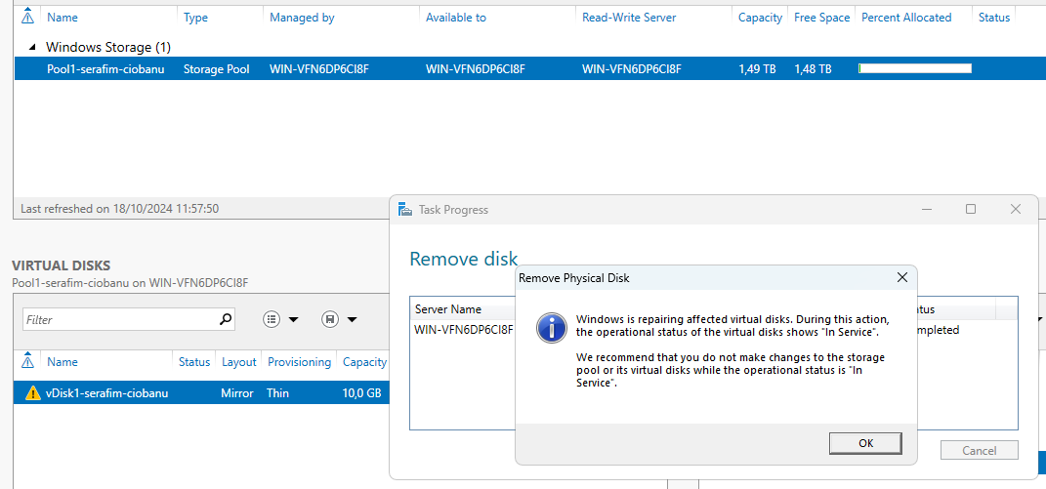

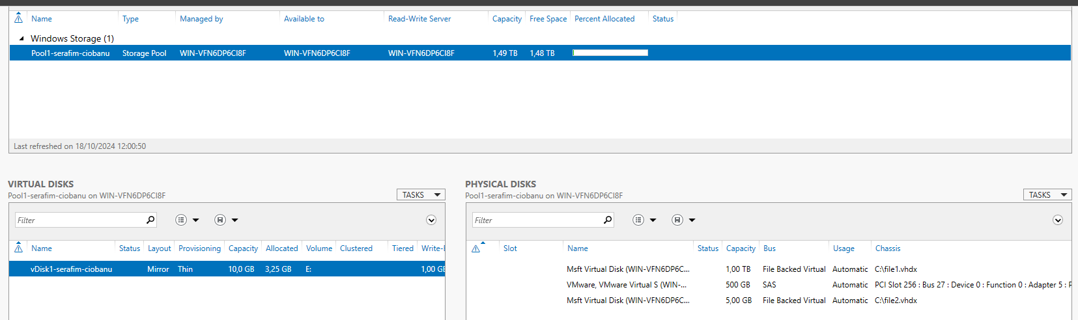

we are back in business

# Data Deduplication

## Preface

Data Deduplication is actually an NTFS feature, so it sits on top of the File System and not really the Storage Subarchitecture.

It will scan through all clusters (so cluster size plays a role) and when it finds duplicates it will mark that cluster as a “sparse” cluster, remove the data and create a link to the Chunk Store.

*Data Deduplication explained*

## Configuration

Let’s try to get some of our disk space back. The “fsutil” command used in chapter 3 just creates files with zeroes in them. This seems like a good target for Data Deduplication.

However: we first have to install this feature. We can use Server Manager to install the Data Deduplication subrole. Or just open a PowerShell console:

PS> *Add-WindowsFeature -Name FS-Data-Deduplication*

We can configure Data Deduplication perfectly via PowerShell

Hint: <https://www.jorgebernhardt.com/how-to-implement-data-deduplication-using-powershell/>

But let’s use Windows Server Manager once again, open it and navigate to File and Storage Services > Volumes.

**Q: Why can’t we enable Deduplication on the system disk?**

**It is not safe to have system files deduplicated (and there is no use for it really), in case a sector becomes corrupt**

1. So configure Data Deduplication for the Storage Pool Virtual Disk Volume

It has been like 2 weeks since I touched this lab, so probably it means the virtual disk volume

* 1. Select the “Virtual Desktop Infrastructure” profile, it works quite aggressively and often results in the largest savings possible.
  2. Change the age to 0 days

* 1. Do not exclude any extra extensions, folders or files. Take a look at the options within “Deduplication Schedule”.  
     **Q: Why is the “Enable throughput optimization” very convenient?**

**It is going to use what it needs, not really affecting the system itself, hence also not outputting data deduplication for later.**

1. We notice that the savings are 0% at first, the actual deduplication process works via a scheduled task that runs once a day. But we can force it to start via PowerShell:

  
Start a PowerShell session (if not running):

* 1. PS> *Get-DedupSchedule* Take note when the next Scrubbing is supposed to start

* 1. PS> *Get-Help Start-DedupJob*  
     PS> *Start-DedupJob E: -Type Optimization*

* 1. Follow the progress with:  
     PS> *Get-DedupStatus*PS> *Get-DedupJob*

* 1. Once the job is completed, check the final savings rate:

PS> *Get-DedupStatus | select SavingsRate*

1. Eventually it should be visible in the Server Manager as well:

*Before*

*After*

**Q: Although very powerful, Data Deduplication has several large downsides:**

- Try to find out what the concept of “Fragmentation” on spinning disks is and why data deduplication is, generally spoken, a bad idea to configure on regular, spinning hard drives?

There is also a process called defragmentation, which brings chunks of data closer to each other, regarding the same files. Overall that process is meant to make the seeking times faster, as considering the speeds of spinning for the HDD, and the fact that you may have consecutive blocks of data, it would make it faster overall. Deduplication saves the data in some different chunks (as in it makes new chunks of the same data that is spread across the same files), hence it probably makes it harder and slower to find the data.

- What would data deduplication do with the CPU load and the overall performance of your data transfer speeds?

We saw in the settings the optimization options, and considering that, I might think it will make the CPU more loaded, and technically when you have a very big load of data and not just 10gb worth of it like in a VM, then it might be really a hassle to process all of that information. Hence data deduplication is probably something to run along with backups, since then you get less space used, and make the necessary backups (even though I might be wrong in my current sentence)

# iSCSI server

## Preface

As clearly visible on the ‘Volumes’ view in ‘File and Storage Services’ (see previous step), Windows Server also supports being an iSCSI Target Server (next to being an iSCSI Initiator).

We first need to install the role and then we can configure iSCSI Targets and LUNs.

## Configure iSCSI

Let’s configure iSCSI

1. Using PowerShell or Server Manager, install the ‘iSCSI Target Server’ and ‘iSCSI Target Storage Provider’ subrole

1. Before being able to create a target, we need LUNs in the form of Virtual Disks
   1. Open Disk Manager to manually create a new VHD
   2. Create a new 2TB VHDX “c:\iscsi-<firstname>-<lastname>.vhdx” . Then, detach it immediately. (Required for iSCSI)

1. Back in Server Manager, open “File and Storage Services” > “iSCSI”
   1. Under Tasks, select import iSCSI Virtual Disk.

* 1. Proceed with creating a Target “FirstTarget-<firstname>-<lastname>”

* 1. Within the step “Access Servers”, select IQN as the access server and use wildcard “*” as the value.

*Our first iSCSI Target, open to all!*

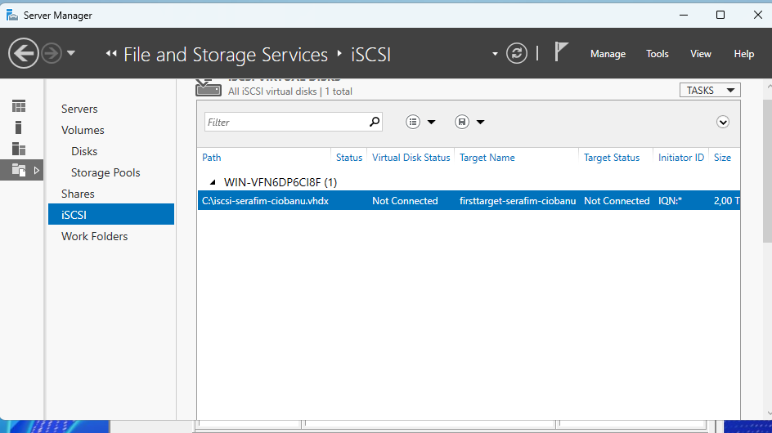

1. Now use any client on your laptop host (e.g. the Windows iSCSI Initiator) and connect to this LUN.
   1. On the client (your laptop host): verify that you have the disk now remotely attached in your Disk Management.

I also had to initialize it (I did GPT of course)

* 1. On the Target Server: get a list of connected clients and find the initiator IQN of your laptop host.

**Q: After connecting to your iSCSI Target take a screenshot of your 'iSCSI Targets' (bottom pane) in Server Manager in the 'iSCSI' section within 'File and Storage Services'. iSCSI disk and target should include your name**

1. Now create a new 2TB VHDX “c:\iscsi-extra-<firstname>-<lastname>.vhdx” and detach immediately, just like before. Import this new disk (i.e. a new LUN) to the iSCSI virtual disks and assign it to the same iSCSI target ‘firsttarget-<firstname>-<lastname>’.

**Q: Is something needed on the initiator side to make this extra disk (LUN) visible?**

I managed to just refresh the view in the iSCSI Initiator, but I think it would appear like doing nothing. When importing the VHD into the other iSCSI target, it also just worked easily and appeared as connected.

